Task 1:
A tree is a type of data structure that represents a hierarchical relationship between data elements, called nodes. The top node in the tree is called the root, and the elements below the root are called child nodes. Each child node may have one or more child nodes of its own, forming a branching structure. The nodes at the bottom of the tree, which do not have any child nodes, are called leaf nodes. In this article, we will learn about different applications of Tree Data Structure.
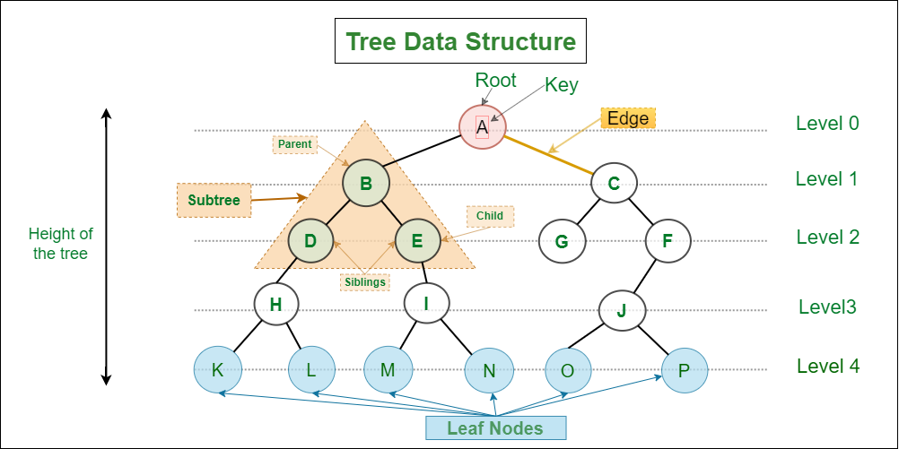

Task7:
Binary trees are a fundamental data structure with various classifications based on their structure and properties. The main types of binary trees are:
- Full Binary Tree (or Strict/Proper Binary Tree):
In a full binary tree, every node has either zero or two children. No node has only one child.
- Complete Binary Tree:
A complete binary tree is a binary tree where all levels are completely filled except possibly the last level, and in the last level, all nodes are as far left as possible.
- Perfect Binary Tree:
A perfect binary tree is a special case that is both a full and a complete binary tree. All internal nodes have two children, and all leaf nodes are at the same level (depth).
- Degenerate (or Pathological) Binary Tree:
In a degenerate binary tree, each parent node has only one child node. This results in a tree that resembles a linked list, either left-skewed (all nodes lean left) or right-skewed (all nodes lean right).
- Balanced Binary Tree:
A balanced binary tree is one where the heights of the left and right subtrees of any node differ by at most one. This property helps maintain efficient search, insertion, and deletion operations. Examples include AVL trees and Red-Black trees.
- Skewed Binary Tree:
This is a specific type of degenerate tree where all nodes are either on the left side (left-skewed) or the right side (right-skewed).
- Binary Search Tree (BST):
While not a structural type in the same sense as the above, a BST is a widely used type of binary tree where nodes are ordered. For every node, all values in its left subtree are less than the node's value, and all values in its right subtree are greater than the node's value.
- Heap (Min-Heap/Max-Heap):
Heaps are tree-based data structures that satisfy the heap property, which dictates a specific ordering between parent and child nodes. In a max-heap, the parent node's value is greater than or equal to its children's, while in a min-heap, it's less than or equal to its children's.

